Landing Page
- Search Bar + Suggestions
- Search by Voice or Text
- Detect-Location
- Sign-In as a Customer or as an Agent

Search Suggestions

UX
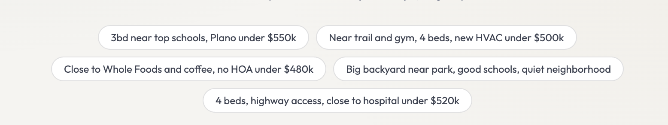

Data needed for Search Suggestions
- Number of Beds, Bath, Sq. Ft, Year
- Price
- Schools Info
- All the info - which others are already pulling
- Near-by (see below for detailed)

Nearby (things to consider)
Source: Google Places API
- Trail
- Gym
- Close to Wholefoods
- Coffee
- Park
- Highway access
- Hospital
- Sports activities

Other Factors
- Quiet neighborhood
- New HVAC

Search Results

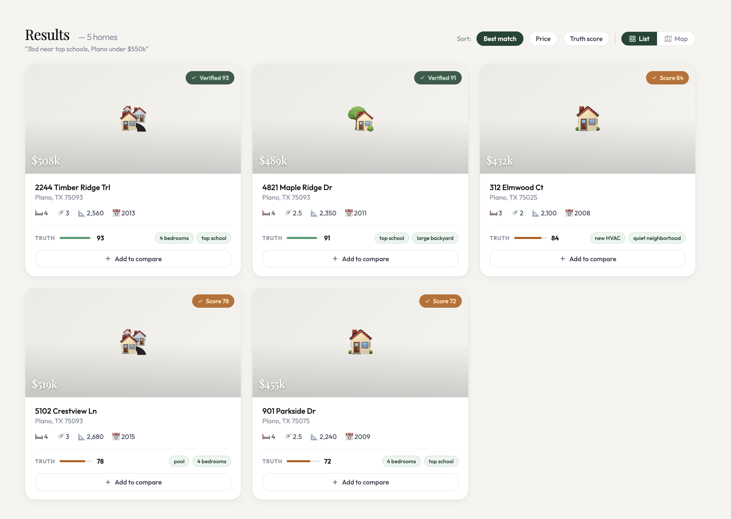

Summary of Results
- List of Homes (call it Home-Cards)
- Each Home-Card shows
- Price
- Address
- Number of Beds, Baths, Sq. Foot, Year
- Truth Score
- Verified Badge (or Score Badge)
- Factors that matched: Top School, new HVAC

Changing the view of Search Results
- Switch between the List & Map View
- Sort by – Best match, price, Truth Score

Actions you can take on each Home
- View details Click anywhere on the card - to go to ‘Listing Detail’
- Compare Homes click on [Add to Compare]

Comparing Homes

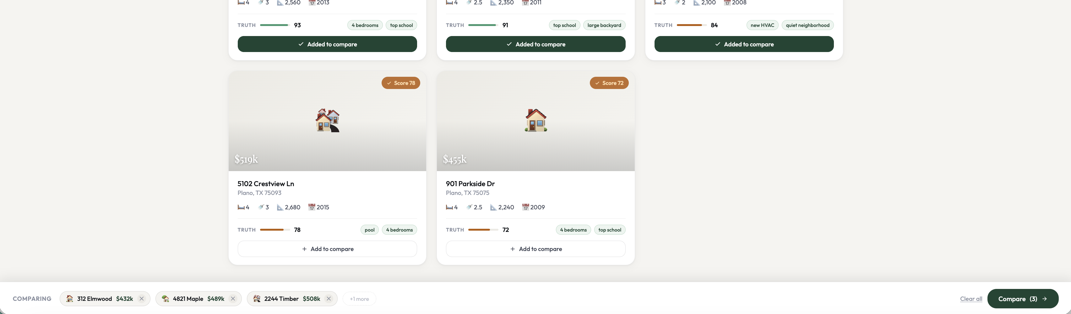

‘Comparing’ Bar at the bottom to launch ‘Compare Homes’

Compare Homes (Modal)
- Key Specs. - Price, Price/Sq Ft, Bedrooms, Bathrooms, Sq Foot, Year build, HOA, Truth Score

- Lifestyle Proximity (Drive Time) - Grocery, Gym, Trail, Park, Highway, Hospital
Source: Google – Places API

- Pros & Cons – Source: Model generated

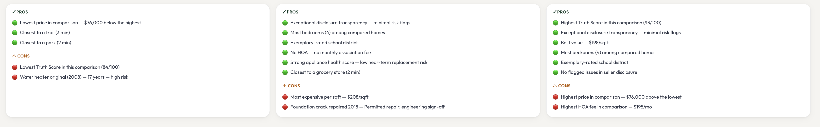

Listing Details
- Price & Address at the top
- Various Sections within Listing Detail

Property Details - Number of Bedrooms, bathrooms, Sq. Ft, Year build, number of garages, HOA
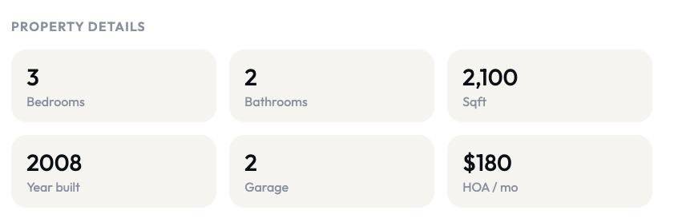

Truth Score
Source – To dig into, the source of the info & the comp to come up with each score
- Data Accuracy
- Image Authenticity
- Listing consistency
- Appliance Health
- Certification
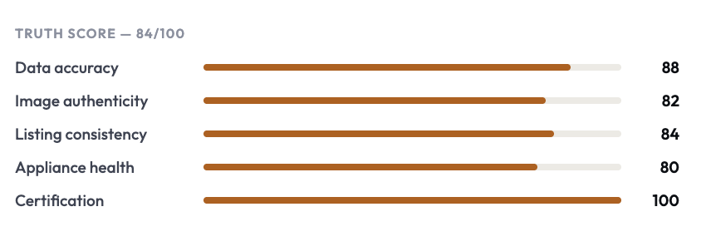

Seller Disclosure
Source: Seller Disclosure Agreement
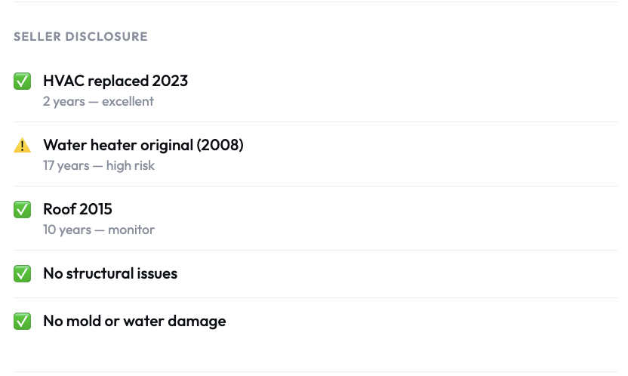

School District
Source: could be an API we can call to get School-District based on Address
- https://developer.schooldigger.com/
- https://www.greatschools.org/api

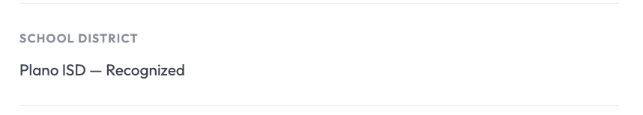

Lifestyle Map
Source: customize Google Maps using various criteria (coffee, gym) and pin the locations
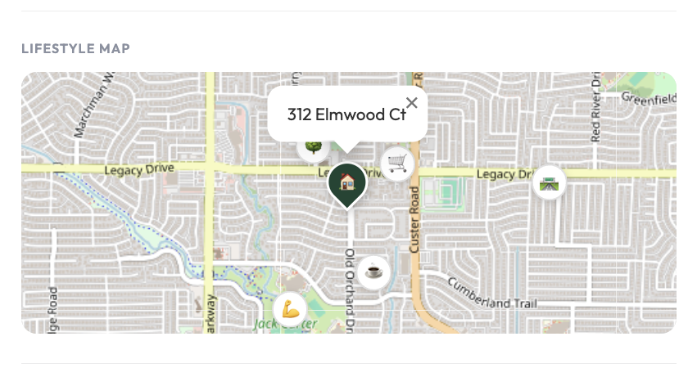

Nearby Places
Source: https://developers.google.com/maps/documentation/places/web-service/nearby-search

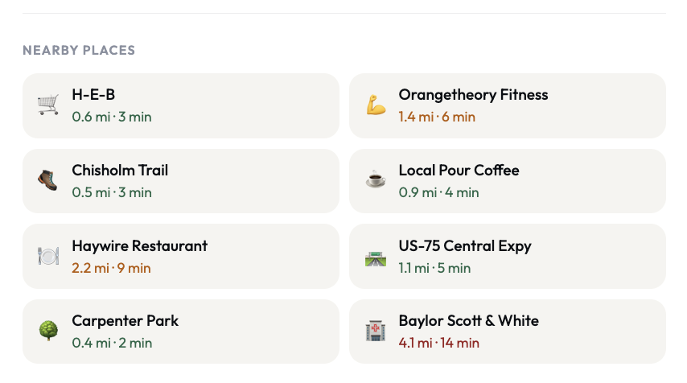

Schedule a showing


